What will we be learning?  Paper 2  Section 5 – Health, fitness, and well-being | Why this? Why now?  GCSE PHYSICAL EDUCATION  SECTION 2 (Paper 2)  This unit is taught in Year 11 but will be also taught in smaller elements within other topics in Year 10.  There is also a practical element to this unit that will link into the AEP written coursework.  You will develop your knowledge and understanding of the benefits of taking part in physical activity and sport and be able to link this to health, fitness and well-being. You will know about the physical, emotional and social benefits as well as the consequences of a sedentary lifestyle. You will develop their knowledge and understanding of diet and nutrition. You will understand the main components of a balanced diet, including the effects of these components and hydration on performers using a range of examples from physical activities and sports. | Key Words:  Health  Fitness  Well being  Sedentary lifestyle  Injury  Coronary heart disease  Blood pressure  Bone density  Obesity  Type 2 diabetes  Posture  Self-esteem/ confidence  Stress management  Image  Friendship  Belonging to a group  Loneliness  Age groups  Data  Diet  Nutrition  Carbohydrates  Proteins  Fats  Minerals  Vitamins  Fibre  Water  Hydration
What will we learn?
5.1 Health, fitness, and well-being
5.2 Diet and nutrition

What opportunities are there for wider study?
Sixth form studies
- Cam Tech Sport
- A level PE
Careers/degree courses
- Sports science
- Physiotherapy
- PE teacher
How will I be assessed?
- Paper 2 (30%) 60 marks – 1 hour
- AEP Written Coursework

5.1 HEALTH FITNESS AND WELL-BEING  Health, fitness, and well-being  - Know what is meant by health, fitness, and well-being.  - Understand the different health benefits of physical activity and consequences of a sedentary lifestyle:  - Physical: injury – coronary heart disease (CHD) – blood pressure – bone density – obesity – Type 2 diabetes – posture – fitness  - Emotional: – self-esteem/confidence – stress management – image  - Social: – friendship – belonging to a group – loneliness  - Be able to apply the above to different age groups.  - Be able to respond to data about health, fitness, and well-being. | 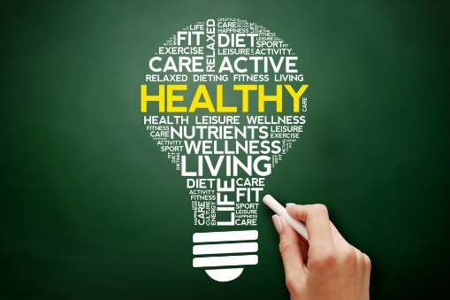
5.2 DIET AND NUTRITION  Diet and nutrition  - Know the definition of a balanced diet.  - Know the components of a balanced diet: carbohydrates, proteins, fats, minerals, vitamins, fibre, water, and hydration.  - Understand the effect of diet and hydration on energy use in physical activity.  - Be able to apply practical examples from physical activity and sport to diet and hydration. | 